SIMATS ENGINEERING (SAVEETHA SCHOOL OF ENGINEERING)
Department of Artificial Intelligence and Data Science
ASSESSMENT TOOL 1 – APPLICATION BASED QUESTIONS

Course Code: | DSA0307 | Course Title: | Natural Language Processing
CO Assessed: | CO1 – Imitation (L1) | Assessment: | Assessment Tool 1 – Application Based Questions
Weightage: | 40% of CIA
CO1 Statement: | Analyse NLP models, regular expression patterns, finite state automata, morphological processing techniques and to interpret language processing. (BL-3)
Student Name: | S.Sri Sai Prasanna Durga | Reg. No.: | 192424241
Section / Batch: | 2024 | Date:

Code of Conduct
I ___S.Sri Sai Prasanna Durga(192424241) (Name / Reg No) certify that this submission is my original work and that I have adhered to the guidelines specified for this assessment. I understand that any violation of academic integrity rules will result in disciplinary action.
Signature of the Student: _S.Sai Prasanna__________

Instructions
- Develop a modular and efficient Python program that satisfies all the functional requirements specified in the problem statement.
- Demonstrate the correctness of the implementation using suitable test cases and justify the output obtained.
- Follow good programming practices, including meaningful variable names, proper code indentation, comments, and error handling wherever applicable.
- Duration: 30 minutes.

Section / Topic | Focus | Q Nos
Information Extraction | Regex-Based Information Extraction | 1
Pattern Matching | Regex Pattern Matching | 2
Regular Expression Patterns | Regex-Based Input Validation | 3

Annexure A – Application Based Questions

Section 1: Regular Expressions – Resume Information Extraction
- A multinational recruitment company receives thousands of resumes every day in text format. The HR department requires an automated system to extract candidate information for shortlisting.

Design and implement a Python-based resume information extraction system using Regular Expressions that performs the following tasks:

Extract the candidate's name.
Identify email addresses.
Extract mobile numbers.
Detect technical skills (Python, Java, SQL, Machine Learning, NLP).
Extract years of experience.
Generate a structured summary of the candidate's profile.
Display candidates who satisfy the minimum eligibility criteria (minimum 2 years of experience and Python skill).

Section 2: Regular Expressions – Product Search System
- An e-commerce company plans to enhance its product search engine to improve customer experience through flexible keyword matching.

Design and implement a Python-based product search system using Regular Expressions that performs the following tasks:

Search products using an exact keyword.
Perform prefix-based searches.
Perform suffix-based searches.
Search using partial keywords.
Perform case-insensitive searches.
Display all matching product names.
Generate a report showing the total number of matching products for each search.
Section 3: Regular Expressions – University Registration System
A university is developing an automated online registration portal to verify student information before course enrollment.

Design and implement a Python-based validation system using Regular Expressions that performs the following tasks:

Validate the student register number.
Validate the institutional email address.
Validate the course code.
Validate the semester information.
Validate the student's mobile number.
Display appropriate validation messages for each field.
Generate a final registration status report indicating whether the registration is successful.

Q1: Regular Expressions – Resume Information Extraction
1. Understanding of Problem Context:
A multinational recruitment company receives thousands of resumes every day. Manually reviewing each resume is time-consuming and may result in errors. The HR department requires an automated system that can extract candidate information such as name, email address, mobile number, technical skills, and years of experience. By using Python Regular Expressions (Regex), the system can automatically analyze resumes, generate candidate profiles, and shortlist eligible candidates based on predefined criteria.
2.Application of Concepts:
Concept Used
- Python Programming
- Regular Expressions (Regex)
- Pattern Matching
- Information Extraction

Regex Patterns Used
Field | Regex Pattern
Name | Name:\s*(.*)
Email | [A-Za-z0-9._%+-]+@[A-Za-z0-9.-]+\.[A-Za-z]{2,}
Mobile Number | [6-9]\d{9}
Skills | Python|Java|SQL|Machine Learning|NLP
Experience | (\d+)\s+years

Python Functions Used
- re.search()
- re.findall()
- group()
These concepts are applied to identify and extract candidate information from the resume text efficiently.

3. Problem-Solving Approach:
Algorithm
Step 1: Import the re module.
Step 2: Read the resume text.
Step 3: Extract the candidate name using Regex.
Step 4: Extract the email address.
Step 5: Extract the mobile number.
Step 6: Extract technical skills.
Step 7: Extract years of experience.
Step 8: Display the extracted details.
Step 9: Check whether:
- Experience ≥ 2 years
- Python skill is available
Step 10: If both conditions are satisfied, display "Eligible for Shortlisting"; otherwise display "Not Eligible".
Step 11: Stop.
4.Accuracy of Solution:
Code:
import re
resume = """
Name: Sai Prassana
Email: sai123@gmail.com
Mobile: 9876543210
Skills: Python, SQL, Machine Learning, NLP
Experience: 3 years
"""
name = re.search(r"Name:\s*(.*)", resume)
email = re.findall(r"[A-Za-z0-9._%+-]+@[A-Za-z0-9.-]+\.[A-Za-z]{2,}", resume)
mobile = re.findall(r"[6-9]\d{9}", resume)
skills = re.findall(r"Python|Java|SQL|Machine Learning|NLP", resume)
experience = re.search(r"(\d+)\s+years", resume)
print("Candidate Name:", name.group(1))
print("Email:", email)
print("Mobile:", mobile)
print("Skills:", skills)
print("Experience:", experience.group(1), "Years")
if "Python" in skills and int(experience.group(1)) >= 2:
print("Eligible for Shortlisting")
else:
print("Not Eligible")
Output:
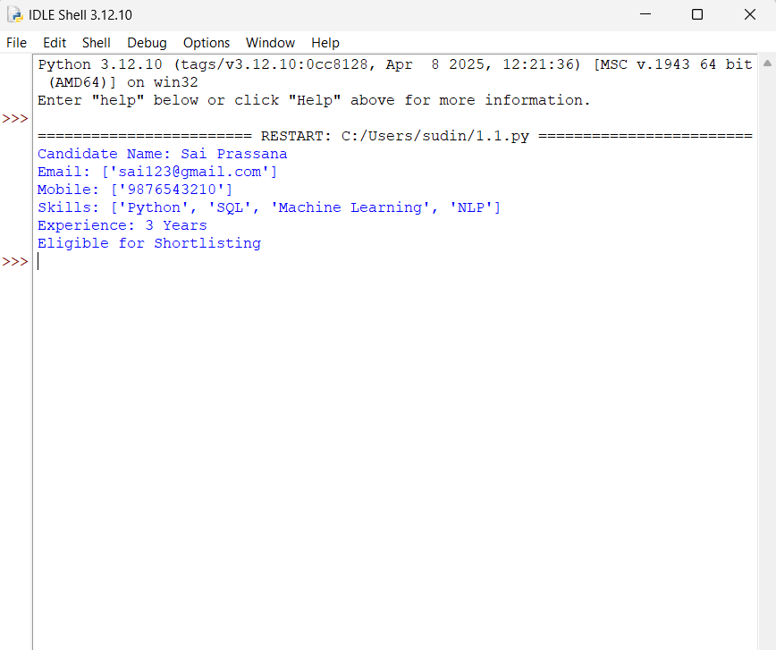
Test Cases
Experience | Python Skill | Result
3 Years | Yes | Eligible
1 Year | Yes | Not Eligible
5 Years | No | Not Eligible

5. Clarity:
Output Explanation
The program successfully extracts the candidate's name, email address, mobile number, technical skills, and years of experience from the resume using Regular Expressions. It then checks whether the candidate has at least 2 years of experience and possesses Python as one of the technical skills. If both conditions are satisfied, the candidate is declared Eligible for Shortlisting; otherwise, the candidate is marked Not Eligible.
Conclusion
The developed Python program effectively automates resume information extraction using Regular Expressions. It reduces manual effort, improves accuracy, and helps the HR department shortlist eligible candidates quickly and efficiently.

Q2: Regular Expressions – Product Search System
1. Understanding of Problem Context:
An e-commerce company maintains a large database of products. Customers search for products using different types of keywords such as exact names, prefixes, suffixes, partial words, or different letter cases. A flexible product search system improves customer experience by quickly locating matching products. Python Regular Expressions (Regex) are used to perform various types of searches and display all matching product names along with the total number of matches.
2. Application of Concepts:
Concepts Used
- Python Programming
- Regular Expressions (Regex)
- Pattern Matching
- String Searching
- Case-Insensitive Search

Regex Patterns Used
Search Type | Regex Pattern
Exact Search | ^keyword$
Prefix Search | ^keyword
Suffix Search | keyword$
Partial Search | keyword
Case-Insensitive Search | re.IGNORECASE
Python Functions Used
- re.search()
- re.match()
- re.IGNORECASE
- len()
These concepts are used to perform flexible product searches and count the matching products.
3. Problem-Solving Approach:
Algorithm
Step 1: Import the re module.
Step 2: Create a list of product names.
Step 3: Read the search keyword from the user.
Step 4: Perform an exact search using Regex.
Step 5: Perform a prefix-based search.
Step 6: Perform a suffix-based search.
Step 7: Perform a partial keyword search.
Step 8: Perform a case-insensitive search.
Step 9: Display all matching products.
Step 10: Count and display the total number of matching products for each search type.
Step 11: Stop.
4.Accuracy of Solution:

Code:
import re
products = [
"Laptop",
"Laptop Bag",
"Mouse",
"Wireless Mouse",
"Keyboard",
"Gaming Keyboard",
"Mobile",
"Smart Mobile",
"Smart Watch",
"Bluetooth Speaker"
]
keyword = input("Enter search keyword: ")
exact = []
prefix = []
suffix = []
partial = []
case = []
for product in products:
if re.fullmatch(keyword, product):
exact.append(product)
if re.match(keyword, product):
prefix.append(product)
if re.search(keyword + r"$", product):
suffix.append(product)
if re.search(keyword, product):
partial.append(product)
if re.search(keyword, product, re.IGNORECASE):
case.append(product)
print("\nExact Search:", exact)
print("Prefix Search:", prefix)
print("Suffix Search:", suffix)
print("Partial Search:", partial)
print("Case-Insensitive Search:", case)
print("\nReport")
print("Exact Matches:", len(exact))
print("Prefix Matches:", len(prefix))
print("Suffix Matches:", len(suffix))
print("Partial Matches:", len(partial))
print("Case-Insensitive Matches:", len(case))
Output:
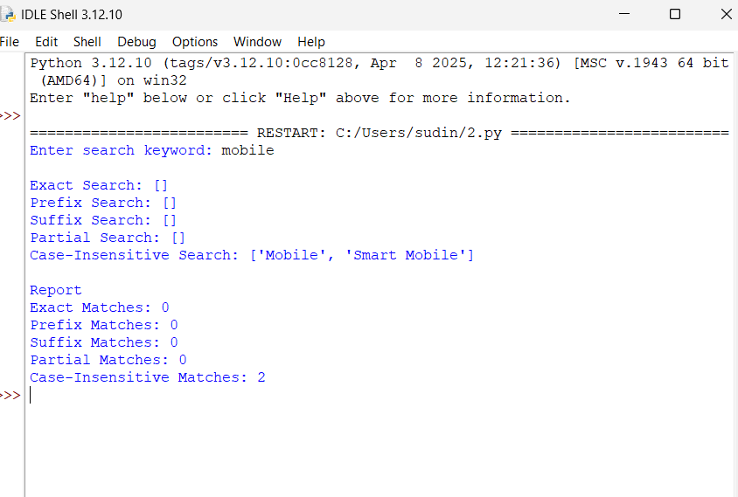
5. Clarity:
Output Explanation
The program stores a list of product names and accepts a search keyword from the user. Using Regular Expressions, it performs five different types of searches:
- Exact Search: Finds products whose name exactly matches the keyword.
- Prefix Search: Finds products that start with the keyword.
- Suffix Search: Finds products that end with the keyword.
- Partial Search: Finds products containing the keyword anywhere in the name.
- Case-Insensitive Search: Finds products regardless of uppercase or lowercase letters.
Finally, the program displays all matching product names and generates a report showing the total number of matches for each search type.
Conclusion
The Product Search System successfully demonstrates the use of Python Regular Expressions for flexible keyword searching. It improves product discovery by supporting multiple search methods and provides an accurate report of matching products. This approach enhances customer experience and makes product searching more efficient.

Q3: Regular Expressions – University Registration System
1. Understanding of Problem Context:
A university is developing an online registration portal to verify student information before course enrollment. Incorrect details such as invalid register numbers, email addresses, course codes, semester information, or mobile numbers may lead to registration errors. Therefore, an automated validation system using Python Regular Expressions (Regex) is required to validate all input fields and ensure that only students with valid information can complete the registration process successfully.
2. Application of Concepts:
Concepts Used
- Python Programming
- Regular Expressions (Regex)
- Input Validation
- Pattern Matching
- Conditional Statements (if-else)
Regex Patterns Used
Field | Regex Pattern | Example
Register Number | ^\d{12}$ | 312223104001
Institutional Email | ^[A-Za-z0-9._%+-]+@saveetha.com$ | student@saveetha.com
Course Code | ^[A-Z]{3}\d{2}$ | DSA03
Semester | ^[1-8]$ | 5
Mobile Number | ^[6-9]\d{9} | 9876543210
Python Functions Used
- re.match()
- input()
- if-else
- print()
These concepts are used to validate each input field according to the university's registration rules.
3. Problem-Solving Approach:
Algorithm
Step 1: Import the re module.
Step 2: Read the student's register number.
Step 3: Read the institutional email address.
Step 4: Read the course code.
Step 5: Read the semester.
Step 6: Read the mobile number.
Step 7: Validate each field using the appropriate Regular Expression.
Step 8: Display "Valid" or "Invalid" for every field.
Step 9: If all fields are valid, display "Registration Successful".
Step 10: Otherwise, display "Registration Failed".
Step 11: Stop.

4. Accuracy of Solution:
Code:
import re
reg_no = input("Enter Register Number: ")
email = input("Enter Institutional Email: ")
course = input("Enter Course Code: ")
semester = input("Enter Semester (1-8): ")
mobile = input("Enter Mobile Number: ")
reg_valid = re.match(r"^\d{12}$", reg_no)
email_valid = re.match(r"^[A-Za-z0-9._%+-]+@saveetha\.com$", email)
course_valid = re.match(r"^[A-Z]{3}\d{2}$", course)
semester_valid = re.match(r"^[1-8]$", semester)
mobile_valid = re.match(r"^[6-9]\d{9}$", mobile)
print("\nValidation Results")
if reg_valid:
print("Register Number : Valid")
else:
print("Register Number : Invalid")
if email_valid:
print("Email : Valid")
else:
print("Email : Invalid")
if course_valid:
print("Course Code : Valid")
else:
print("Course Code : Invalid")
if semester_valid:
print("Semester : Valid")
else:
print("Semester : Invalid")
if mobile_valid:
print("Mobile Number : Valid")
else:
print("Mobile Number : Invalid")
if reg_valid and email_valid and course_valid and semester_valid and mobile_valid:
print("\nRegistration Successful")
else:
print("\nRegistration Failed")
Output:
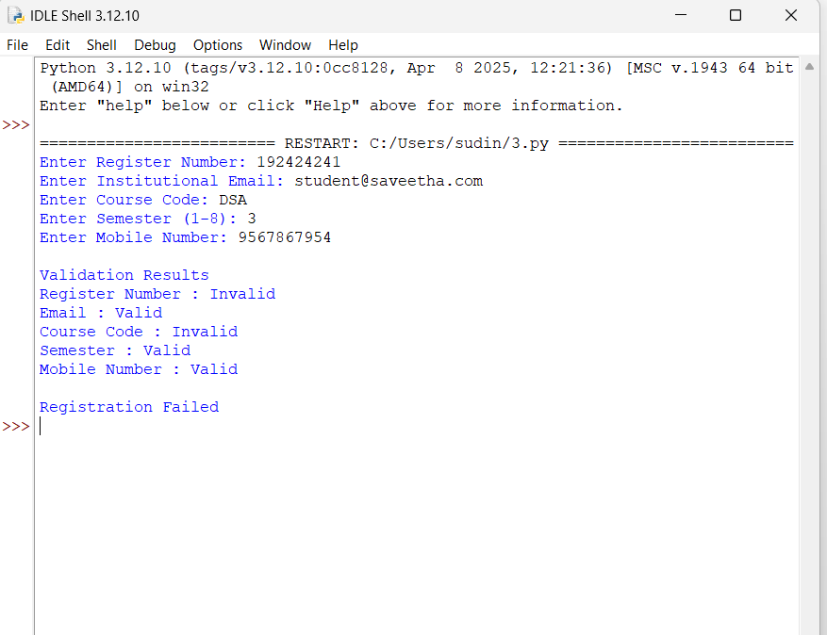

5. Clarity:
Output Explanation
The program accepts the student's register number, institutional email address, course code, semester, and mobile number as input. Each field is validated using an appropriate Regular Expression. The program displays whether each input is Valid or Invalid. If all fields satisfy the required format, the registration is marked as Successful. If any field is invalid, the registration is marked as Failed.
Conclusion
The University Registration Validation System successfully uses Python Regular Expressions to verify student information before registration. It ensures accurate data entry, minimizes registration errors, and automates the validation process. This system improves the efficiency and reliability of the university's online registration portal.

Rubrics for Calculation
Criteria | Weightage | Level 4 – Exemplary | Level 3 – Proficient | Level 2 – Developing | Level 1 – Beginning
Understanding of Problem Context | 20 | Clearly understands the problem and accurately identifies all requirements | Good understanding with minor gaps | Basic understanding; some requirements unclear | Poor understanding or misinterpretation of the problem
Application of Concepts | 30 | Accurately applies appropriate concepts to solve complex problems | Applies relevant concepts correctly with minor errors | Applies basic concepts with limited accuracy | Fails to apply appropriate concepts
Problem-Solving Approach | 20 | Logical, well-structured, and efficient approach | Mostly logical approach with minor gaps | Basic approach with some inconsistencies | Illogical or unclear approach
Accuracy of Solution | 20 | Completely correct solution with proper justification | Mostly correct with minor errors | Partially correct solution | Incorrect or incomplete solution
Clarity | 10 | Clear, well-organized, and properly explained solution | Understandable with minor clarity issues | Limited clarity and explanation | Poorly presented and difficult to understand

Q. No. / Criteria | Understanding of Problem Context | Application of Concepts | Problem-Solving Approach | Accuracy of Solution | Clarity | Sub. Total | Total %
1
2
3

Faculty In-charge | Course Coordinator | Program Director
Signature: _______________ | Signature: _______________ | Signature: _______________
Date: ___________________ | Date: ___________________ | Date: ___________________

